**FORCING LOGOUT REDIS PUB-SUB WITH SOCKET.IO ON EXPRESS.JS**

REF:

<https://www.redisgreen.net/blog/pubsub-howto/>

<https://stackoverflow.com/questions/29785346/redis-client-to-listen-to-set-and-del-events>

<https://stackoverflow.com/questions/18328058/redis-2-8-notifications-get-value-instead-of-key-on-expire>

<https://stackoverflow.com/questions/27210840/node-redis-config-set-command>

<https://redis.io/topics/notifications>

<https://www.sitepoint.com/using-redis-node-js/>

IN ORDER TO ACHIEVE THIS, WE MUST HAVE REDIS ALREADY INSTALLED IN OUR SERVER, AND ALSO WE MUST HAVE REDIS DEPENDENCIES INSTALLED ON NODE WITH NPM

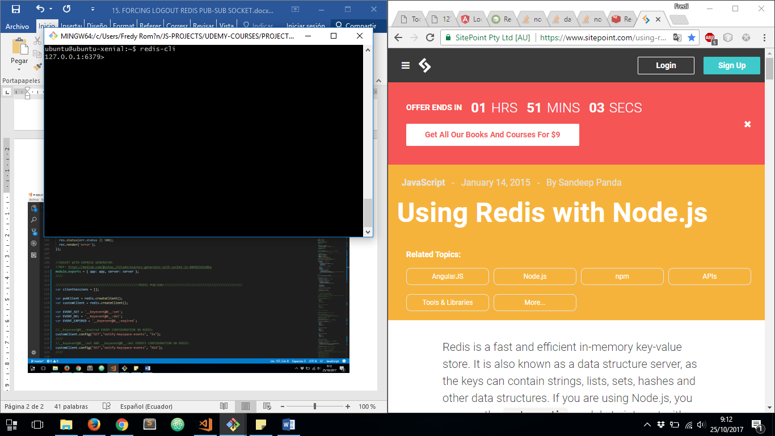

***app.js*** FILE

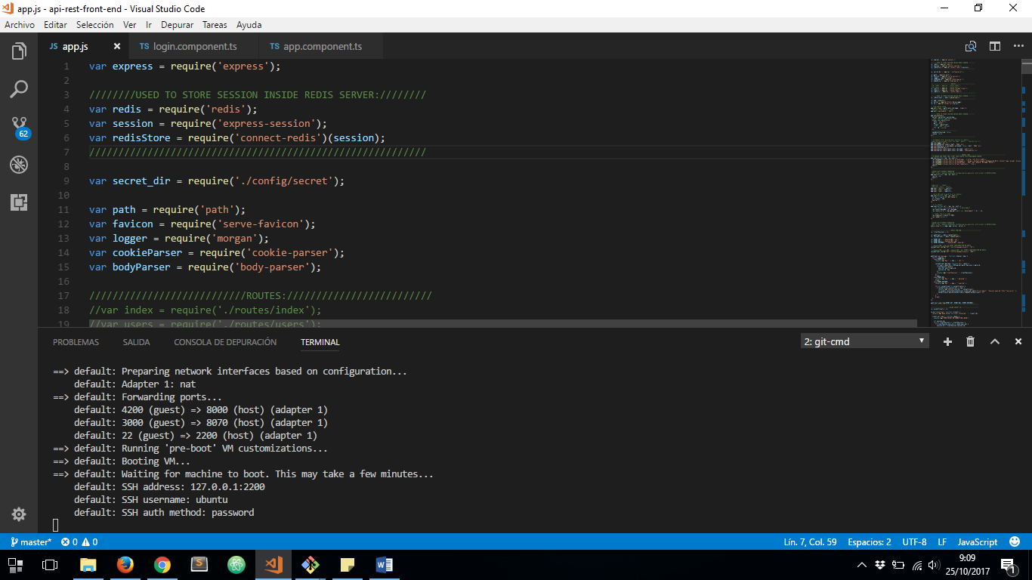

NOW WE HAVE TO CREATE TWO NEW REDIS INSTANCES, AND THEN CONFIGURE KEYSPACE EVENTS TO CATCH PUB/SUB ***set, delete*** AND ***expired*** EVENTS:

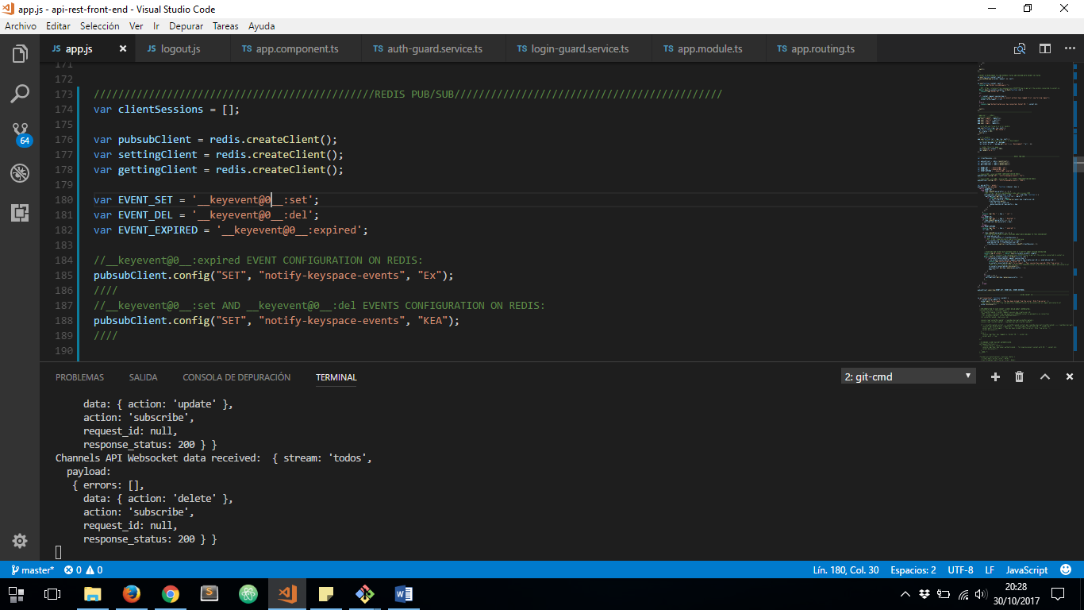

NOW, BEFORE WE CONFIGURE SUBSCRIPTION TO KEYSPACE EVENTS, WE HAVE TO CONFIGURE PROCESS TO BE EXECUTED WHEN SET, DEL AND EXPIRE KEYS:

ON ***SET*** EVENT WE HAVE TO SAVE THE SESSION KEY NAME ON AN ARRAY AND ASSOCIATED IT WITH THE USER ID GENERATED AUTOMATICALLY ON LOGIN. WE HAVE TO USE ONE OF REDIS CLIENTS TO GET DATA FROM KEY JUST SETTED. AND TO MAKE SESSION EXPIRED NOTIFICATIONS, WE HAVE TO SAVE ANOTHER SESSION ASOCIATED TO MAIN SESSION KEY WHICH IS AUXILIAR AND WILL BE USED ONLY TO HANDLE DATA FROM EXPIRED KEY AND FORWARD IT TO THE SPECIFIC CLIENT:

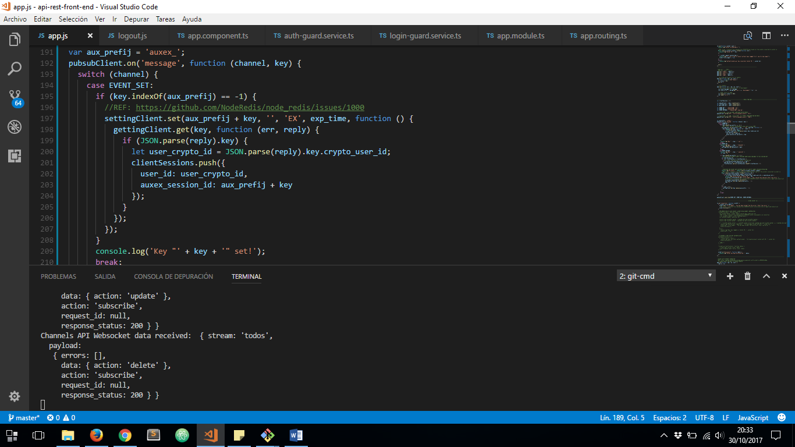

ON ***DEL*** EVENT, IS THE EVENT FIRED WHEN CLIENT MAKES LOGOUT, AND ON IT WE HAVE TO DELETE AUXILIAR SESSION KEY WHEN ITS MAIN SESSION KEY BE DELETED:

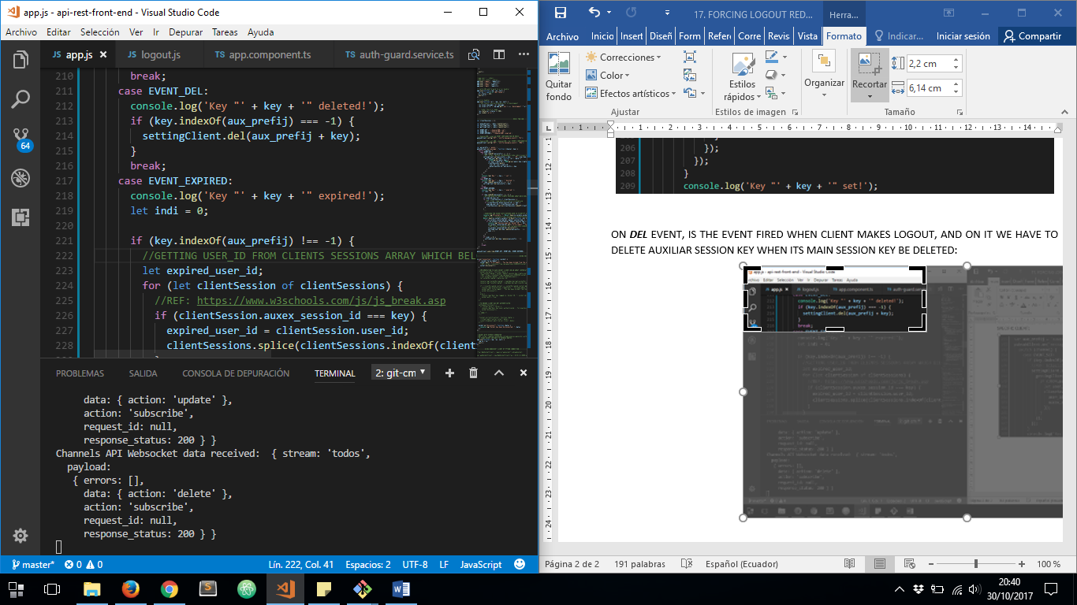

ON ***EXPIRED*** EVENT, WE WILL DO EXACTLY WE WANT, TO NOTIFY CLIENT HIS SESSION HAS EXPIRED:

1. WE HAVE TO LOCALIZE USER_ID ASSOCIATED TO SOME AUXILIAR SESSION KEY WHICH IT’S ALREADY EXPIRED

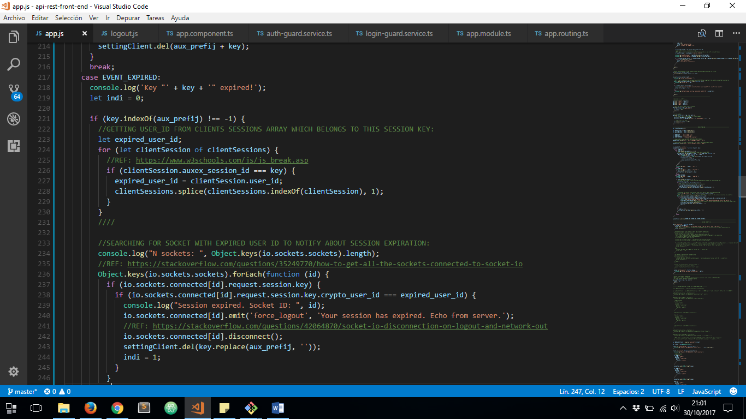

1. WE HAVE TO SEARCH FOR A SOCKET CLIENT WHICH HAS ON ITS SESSION KEY THE USER ID WE HAVE LOCALIZED ABOVE. THEN WE HAVE TO NOTIFY SESSION EXPIRED TO SOCKET CLIENT, DISCONNECT THE SOCKET CLIENT AND REMOVE THE MAIN SESSION KEY.

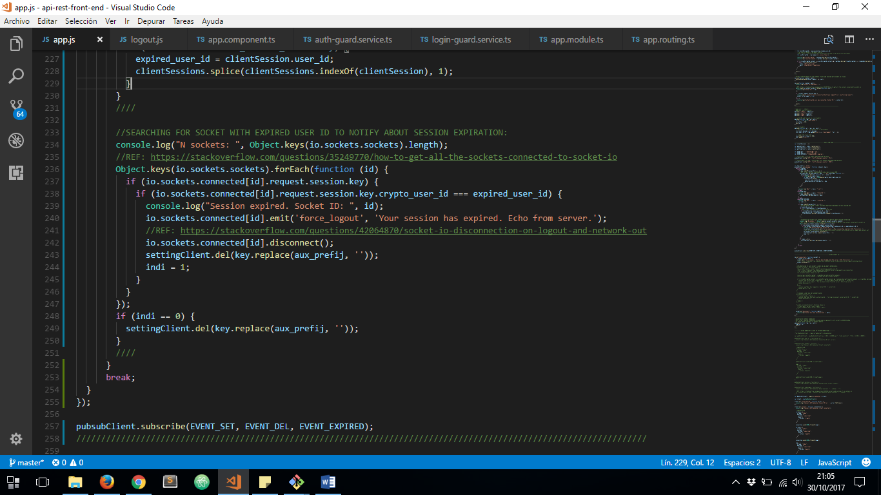

1. FINNALLY IF WE DON’T FIND ANY SOCKET CLIENT ASSOCIATE TO USER_ID LOCALIZED, WE HAVE TO DELETE MAIN SESSION KEY INSTEAD.



THEN IN ANGULAR 4 FRONTEND WE HAVE TO SPECIFY SOCKET CONNECTION EXACTLY AFTER LOGIN, THEN CATCH FORCED LOGOUT NOTIFICATION:

***login.component.ts*** FILE:

1. SAVE USER CREDENTIALS ID ON LOCAL STORAGE
2. REDIRECT TO HOME COMPONENT TO MAKE SOCKET CONNECTION ON

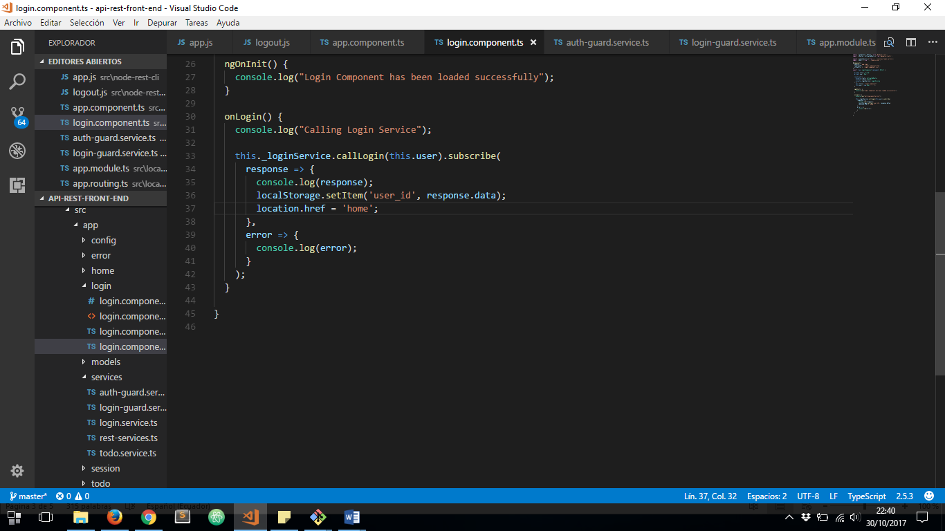

***app.component.ts*** FILE:

1. CHECK IF USER IS ALREADY LOGGED
2. CONNECT TO SOCKET
3. CALL ***ON FORCE_LOGOUT*** SOCKET EVENT

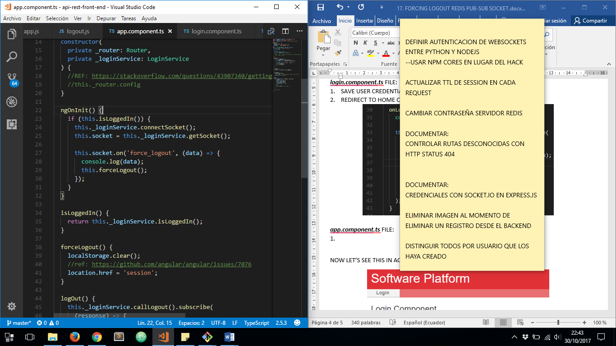

NOW LET’S SEE THIS IN ACTION:

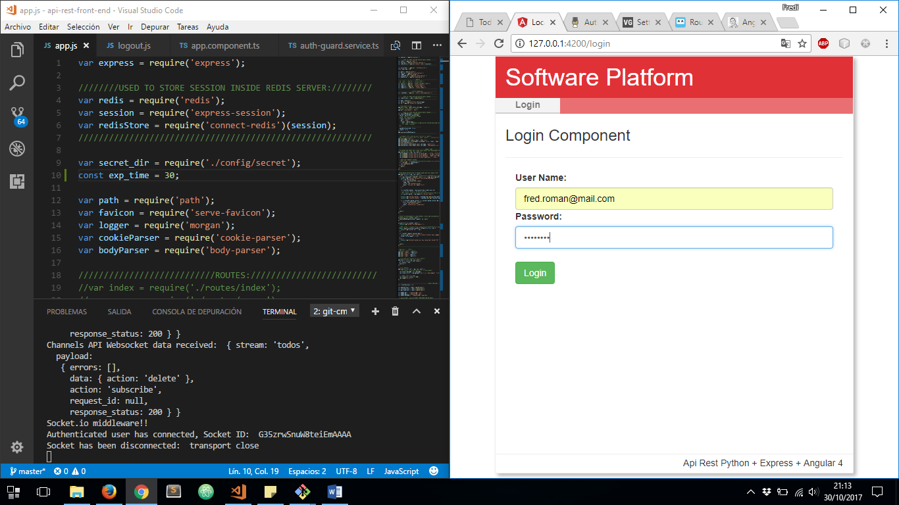

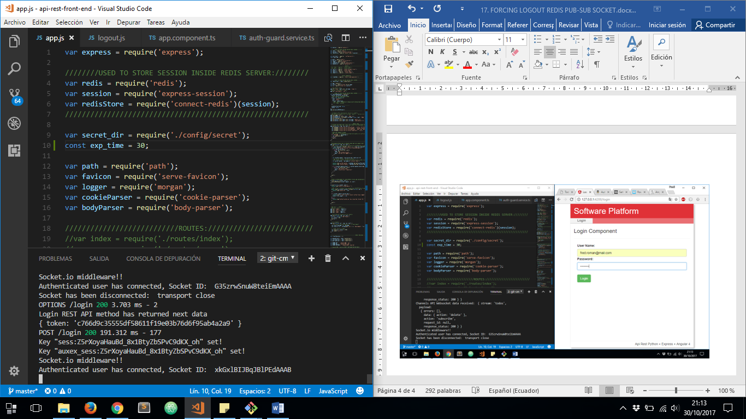

NOW SESSIO HAS EXPIRED:

